Access Control Using Radio Frequency Identification (RFID) Sensor

COMP 492-01 Capstone Project

By: Eyuel Dagne

1. **Project Description** The project started with the aim of creating a secure and efficient door lock system utilizing RFID technology, a powerful tool for access control in secure locations. The primary components of the system include the ELEGOO MEGA2560 R3 microcontroller, the RFID-RC522 module, and the Servo Motor SG90, working together to facilitate a seamless door lock system. Through the different phases from setup to demonstration, the project advanced substantially, adhering to a detailed plan that led to the integration of various elements into a unified system.
2. **Background and Purpose**
   1. Background: The RFID technology, encompassing both active and passive tags, facilitates automatic object identification, metadata recording, and control of individual targets through radio waves. It's commonly used in various sectors including access control, which is the focal point of this project, utilizing RFID as an electronic key to control access to secure locations.
   2. Purpose: To develop a door lock system leveraging RFID technology to enhance security in buildings and safes.
3. **Initial Expectation** The initial expectation for the project was to create a robust and secure door lock system using RFID technology within a 9-week period. This involved not just the creation of a functional system but also comprehensive documentation and testing to ensure its viability in real-world scenarios.
4. **Current State of the Project** Currently, the project has successfully integrated the Arduino coding segments, and the system has been tested and functions as expected. The RFID technology, combined with the ELEGOO MEGA2560 R3 controller and the other components, has been synchronized to achieve the desired door lock mechanism. All project milestones have been met with successful results.
5. **Remaining Areas of Concern** There are no remaining areas of concern as the project has reached completion with all tests showing satisfactory results. The final phase of the project involved documenting the process and outcomes. No significant issues are anticipated. The Arduino code is functioning effectively, and the system's reliability has been established through rigorous testing.
6. **Components Specifications and Descriptions**
   1. **ELEGOO MEGA2560 R3** The ELEGOO MEGA2560 R3 is a versatile microcontroller board powered by the ATmega2560. Capable of being powered via a USB connection or an external source, it comes with an automatic selection mechanism. The board boasts specifications suitable for an array of digital projects, such as:

* Microcontroller: ATmega2560, complemented by controller chips Atmega2560-16au and Atmega16u2.
* Operating Voltage: 5V
* Input Voltage (recommended): 7-9V
* Digital I/O Pins: 54 (15 can provide PWM output)
* Analog Input Pins: 16 DC
* Currents: 40 mA per I/O Pin, 50 mA for 3.3V Pin
* Memory: Flash Memory of 256 KB (8 KB used by bootloader), SRAM: 8 KB, EEPROM: 4 KB
* Clock Speed: 16 MHz
* Physical Attributes: LED_BUILTIN is pin 13; Dimensions: 101.5 mm (L) x 53.3 mm (W); Weight: 34 g
* Additional Processor Specs: Program Memory: Flash, 256 KB; CPU Speed: 16 MIPS/DMIPS; Digital Communication: 4-UART, 5-SPI, 1-I2C; Peripherals: 4 Input Capture, 4 CCP, 16PWM; Timers: 2 (8-bit), 4 (16-bit); Comparators: 1; Temperature: -40 to 85°C; Voltage Range: 1.8 to 5.5V; Pin Count: 100

*Description:* The ELEGOO MEGA2560 R3 offers a powerful platform for a range of digital tasks. Its central processor, the ATmega2560, delivers a plethora of communication peripherals, making it suitable for intricate tasks.

**2. RFID Module: RFID-RC522** The RFID-RC522 is a compact module tailored for reading RFID cards and is based on the MFRC522 controller.

* Frequency: 13.56MHz RFID module
* Operating Voltage: 2.5V to 3.3V
* Communication: SPI, I2C protocol, UART
* Data Rate: Max of 10Mbps
* Reading Range: Approximately 5cm
* Current Consumption: Between 13-26mA; In power down mode: Minimum 10uA

*Description:* The RFID-RC522 is engineered to provide a seamless interface for RFID integration. Its adaptability with various communication protocols ensures flexibility in its applications.

**RC522 Pin description**

|  |  |
| --- | --- |
| **Pin Name** | **Description** |
| Vcc/3.3V | Used to Power the module, typically 3.3V is used |
| RST | Reset pin – used to reset or power down the module |
| Ground | Connected to Ground of system |
| IRQ | Interrupt pin – used to wake up the module when a device comes into range |
| MISO/SCL/Tx | MISO pin when used for SPI communication, acts as SCL for I2c and Tx for UART. |
| MOSI | Master out slave in pin for SPI communication |
| SCK | Serial Clock pin – used to provide clock source |
| SS/SDA/Rx | Acts as Serial input (SS) for SPI communication, SDA for IIC and Rx during UART |

**3. Servo Motor SG90** A high-torque motor, the Servo Motor SG90 stands out for precise angular movements and is frequently employed in robotics.

* Operating Voltage: +5V
* Torque: 2.5kg/cm
* Speed: 0.1s/60° rotation speed
* Gearing: Features plastic gears
* Rotation Capability: Between 0° and 180°
* Physical: Motor weighs approximately 9 grams

*Description:* The Servo Motor SG90, differing from typical DC motors, supplies a geared output that enables controlled rotations, proving invaluable for jobs needing exact angular adjustments.

**Wire Configuration**

|  |  |
| --- | --- |
| **Wire color** | **Description** |
| Brown | Ground wire connected to the ground of system |
| Red | Powers the motor typically +5V is used |
| Orange | PWM signal is given in through this wire to drive the motor |

**4. Additional Components**

* Breadboard: A platform allowing for temporary connections without soldering.
* Buzzer: An audio signaling instrument with diverse applications.
* LED: A power-efficient light source serving as a visual indicator.
* Jumper cables: Essential for creating connections between components.
* Software: Arduino IDE, vital for programming the ELEGOO MEGA2560 R3.

*Description:* The additional components like the breadboard, buzzer, and LED play crucial roles in system feedback and prototyping. Jumper cables ensure seamless interconnections, while the Arduino IDE is an indispensable tool for board programming.

1. **System Architecture** This door access control system utilizes the ELEGOO MEGA2560 R3 microcontroller with an ATmega2560 chip. It communicates with the RFID-RC522 module to check access permissions based on the scanned RFID tag's UID. The SG90 servo motor acts as the door lock, while an LED and buzzer provide visual and auditory feedback.

Software is developed in Arduino IDE, supplemented by an RFID library. After coding, it's uploaded to the microcontroller, then the RFID card and tag are scanned for their UIDs. If an RFID's UID matches the stored UID, access is granted, actuating the servo motor, lighting the green LED, sounding the buzzer, and displaying "Access Granted" on the serial monitor. A mismatch results in denied access, activating the red LED, buzzer, and displaying "Access Denied."

For more in-depth details, refer to appendices A and B, which cover the coding and a demonstration of the system's functionality.

RFID and MEGA 2560 R3 Circuit Pin configuration and photo:

|  |  |
| --- | --- |
| **RFID- RC522 Module** | **MEGA2560 R3** assignment |
| SDA | 53 |
| SCK | 52 |
| MOSI | 51 |
| IRQ | N/A |
| MISO | 50 |
| GND | GND |
| RST | 5 |
| 3.3V | 3.3V |

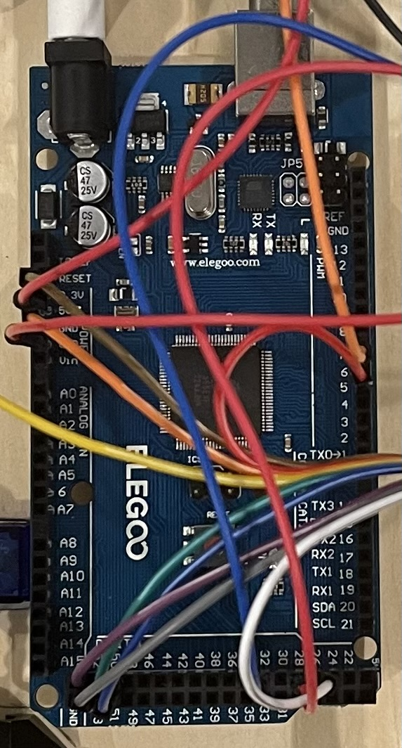a)

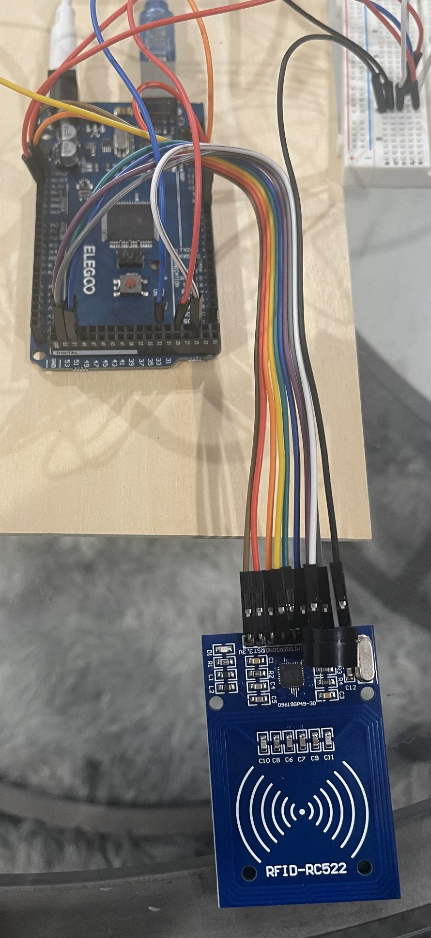b)

Figure 1. (a) and (b) RFID and MEGA 2560 circuit

The overall system pin configuration and Circuit photo:

|  |  |
| --- | --- |
| **RFID- RC522 Module** | **MEGA2560 R3 assignment** |
| SDA | 53 |
| SCK | 52 |
| MOSI | 51 |
| MISO | 50 |
| GND | GND |
| RST | 5 |
| 3.3V | 3.3V |
| **Item** | **Pin** |
| Green Led | GND, 32 |
| Red Led | GND, 28 |
| Buzzer | GDE, 24 |

a)

b)

Figure 2. (a) and (b) the overall system circuit

Figure 3. RFID Tag Unique Identifier UID

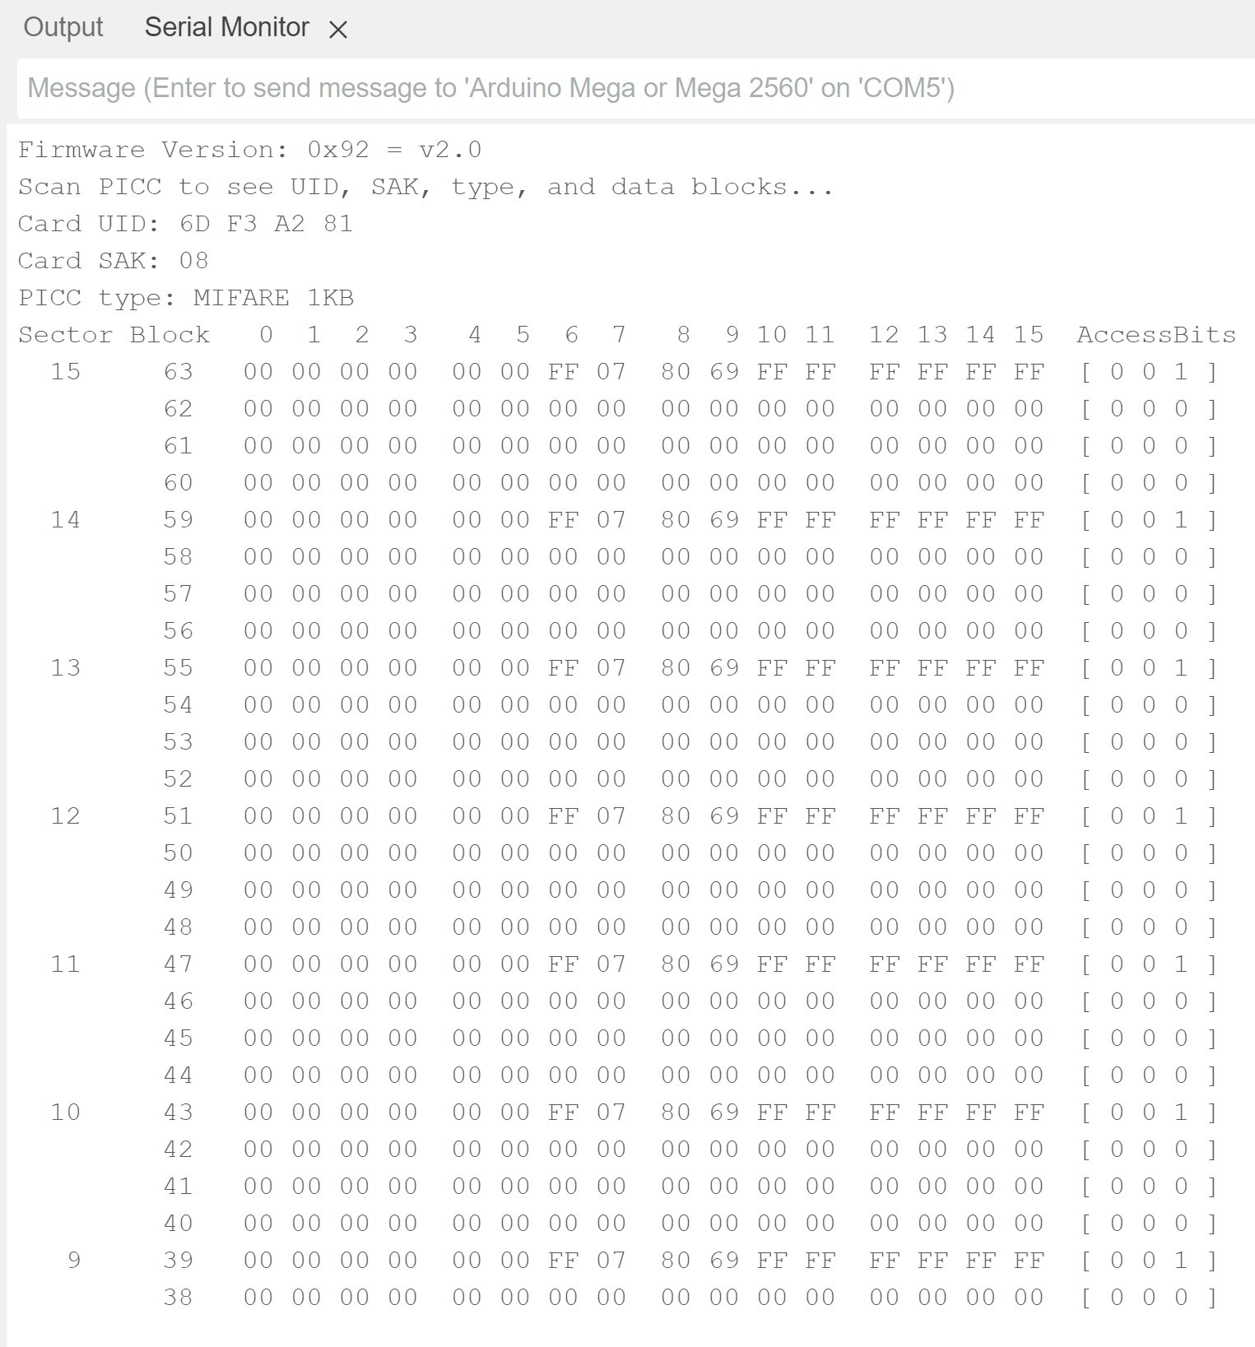

Figure 4. RFID card Unique Identifier UID

1. **Activities and Time Logs**

|  |  |
| --- | --- |
| **Activity** | **Time Spent (weeks and hrs)** |
| Opportunity Study | 1 week – 5 hrs |
| Preliminary Feasibility Judgment | 1 week – 5 hrs |
| Requirement Analysis | 1 week – 6 hrs |
| Requirement Specification | 1 week – 6 hrs |
| Preliminary Design and Planning | 1 week – 6 hrs |
| Design and Coding | 2 weeks – 10 hrs |
| Testing and Integration | 1 week – 5 hrs |
| Documentation | 1 week - 2 hrs |
| **Total Time**: | 9 weeks, 45 hrs. |

1. **Technical Lessons Learned**
   * Understanding and implementing RFID technology in a real-world application.
   * Gained proficiency in working with the Arduino IDE and microcontroller setups.
   * Development of coding skills pertinent to integrating various hardware components.
   * Experience in developing systematic testing strategies to ensure component and system reliability.
2. **Managerial Lessons Learned**

* Learned the importance of a structured approach in managing a time-bound project with various phases.
* Gained insights into efficient self-management and task prioritization to streamline the project workflow.
* Recognized the value of contingency planning, especially with regards to risk management and handling potential system malfunctions and component failures.

1. **Recommendations to Future Projects** For those planning to undertake similar projects in the future, the following recommendations would be instrumental:
   1. Selecting the Topic: Choose a topic that aligns with current technological advancements and has real-world applications.
   2. Selecting the Language/Platform: Choose a platform like Arduino which has a rich community and resources for troubleshooting and learning.
   3. Selecting Team Members: As a sole individual, prioritize developing a diverse skill set that includes both technical and managerial aspects to ensure a comprehensive approach to project execution. If you're working as a group, choose team members with a diverse skill set, encompassing both technical and managerial capacities to ensure a balanced approach to project execution.
   4. Selecting the Time: Allocate sufficient time for each phase of the project, ensuring that crucial aspects such as testing and integration are not rushed, hence maintaining the quality of the project output.
2. **Appendices**
   1. Appendix A

* Arduino code for determining the UID of RFID tags.

* 1. Appendix B
* Final Arduino code used in the project.

**References**

Want, R. (2006). "An Introduction to RFID Technology." Intel Research.

Juels, A. (2006). "RFID Security and Privacy: A Research Survey." RSA Laboratories.

Molnar, D. & Wagner, D. (2004). "Privacy and Security in Library RFID Issues, Practices, and Architectures."

Jia, X., Feng, Q., Fan, T., & Lei, Q. (2012). "RFID Technology and Its Applications in Internet of Things (IoT)."

Finkenzeller, K. (2010). "RFID Handbook: Fundamentals and Applications in Contactless Smart Cards, Radio Frequency Identification and Near-Field Communication." Third Edition. Translated by Muller, D.

Chawla, V. & Ha, D.S. (2007). "Applications & Practice: An Overview of Passive RFID." Virginia Polytechnic Institute and State University.

ELEGOO. (2023). "ELEGOO MEGA 2560 R3 Board." Retrieved from https://www.elegoo.com/products/elegoo-mega-2560-r3-board

Microchip. (2023). "ATmega2560 Product Page." Retrieved from <https://www.microchip.com/wwwproducts/en/ATmega2560>

Components101. (2019). "RC522 RFID Module." Retrieved from https://components101.com/wireless/rc522-rfid-module

Electronics Lab. (2023). "Using SG90 Servo Motor with Arduino." Retrieved from <https://www.electronics-lab.com/project/using-sg90-servo-motor-arduino/>

Components101. (2017). "Servo Motor Basics, Pinout, Datasheet." Retrieved from <https://components101.com/motors/servo-motor-basics-pinout-datasheet>

Arduino Project Hub. (2018). "Arduino RFID: Simulating Simple Access Control System." Retrieved from https://create.arduino.cc/projecthub/KABAKA/arduino-rfid-simulating-simple-access-control-system-798927?ref=tag&ref_id=rfid&offset=30

GitHub. (2023). "Miguelbalboa: rfid." Retrieved from https://github.com/miguelbalboa/rfid

Arduino Project Hub. (2023). "Security Access Using RFID Reader." Retrieved from https://create.arduino.cc/projecthub/Aritro/security-access-using-rfid-reader-f7c746